
3301 N. Mulford Rd., Rockford, Illinois 61114
http://www.rockvalleycollege.edu/library

Guide to Using CINAHL with Full Text

The Cumulative Index to Nursing & Allied Health Literature (CINAHL) provides full text access of 760 journals and summaries of articles an additional 4,000 professional journals in nursing and allied health disciplines. CINAHL offers access to healthcare books, nursing dissertations, selected conference proceedings, standards of practice, educational software in nursing, audiovisuals, care sheets and CEU lessons.

Getting Started
CINAHL is available from both on-campus and off-campus computers. To use the database from home and other off-campus computer, you must have an Internet connection and be a current Rock Valley College student, administrator, faculty or staff member. For instructions on how to access CINAHL with Full Text and many other databases from off-campus, see the guide entitled “Using Library Resources Off-Campus.”

Step 1. Access the Estelle M. Black Library homepage at http://www.rockvalleycollege.edu/library
Step 2. Click the “Library Databases” link in left hand column.
Step 3. Go to the Subject List, select Health and open CINAHL with Full Text
http://www.rockvalleycollege.edu/library Library Homepage

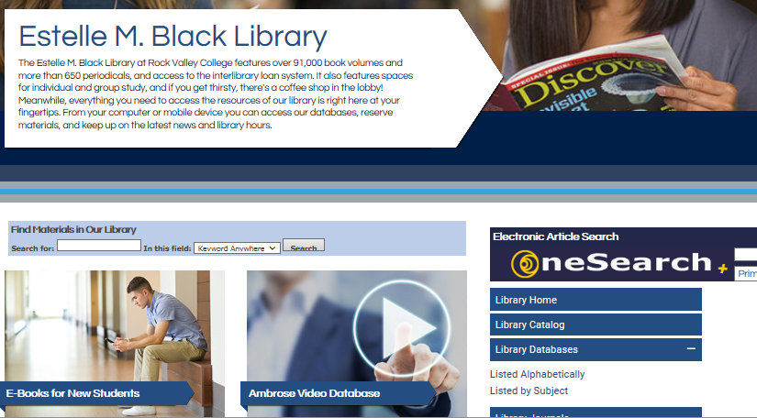
2. Click “Library Databases Listed by Subject”
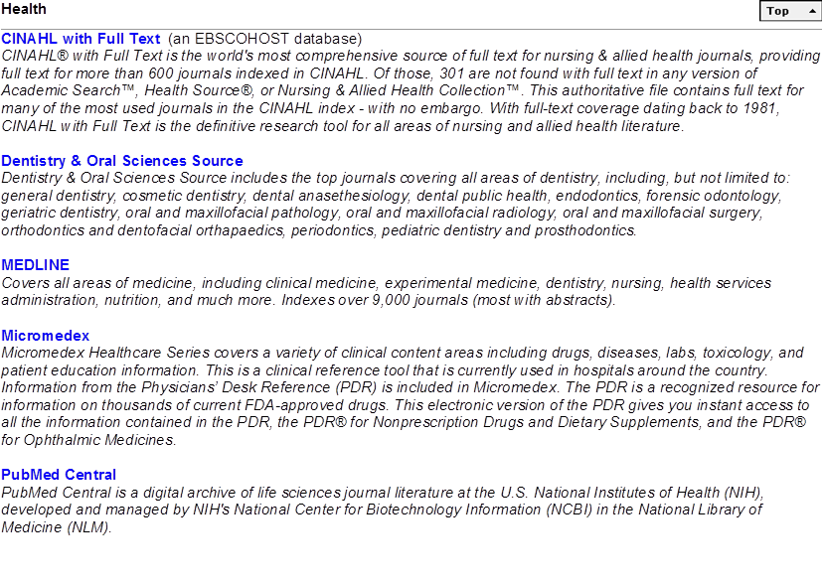
3. Click CINAHLwith Full Text

Figure 1 Start Page for CINAHL with full text
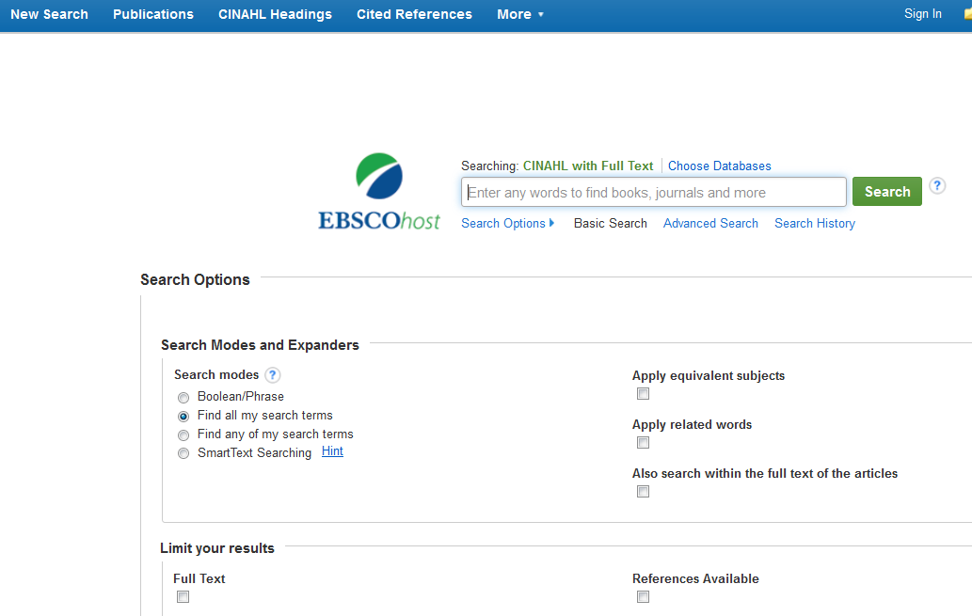

Searching CINAHL with Full Text

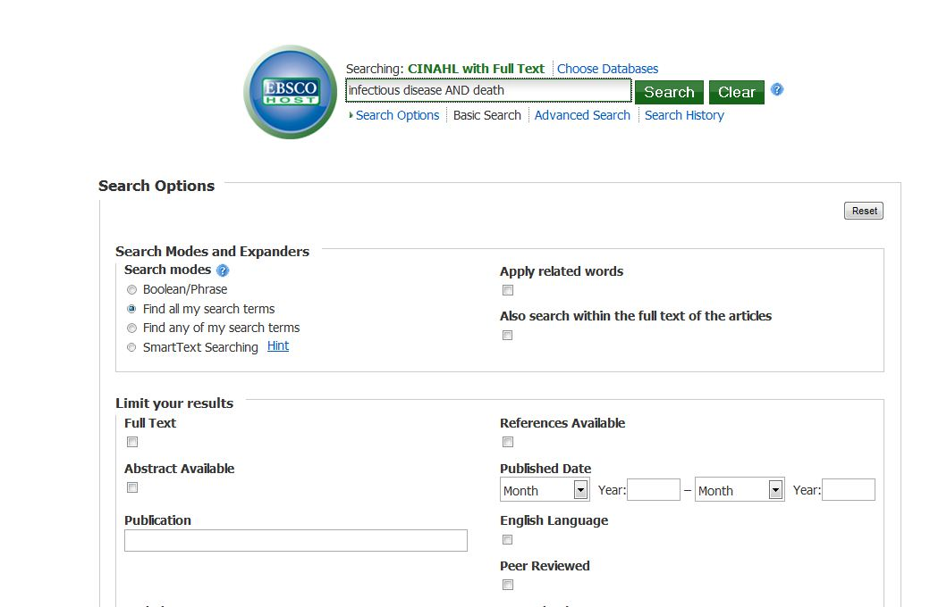
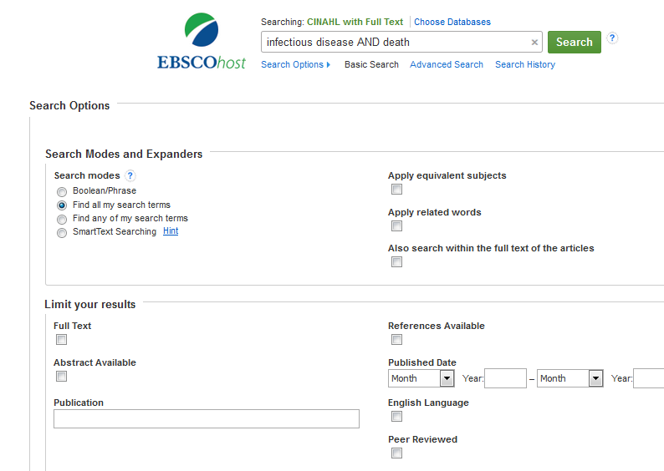
1. Select a search
type
2. Type
search terms here
3. Limit the search as desired.
4. Start the search

1. Select a Search Mode

-Keyword Search (basic or simple search) allows you to type in the keywords you want the computer to match. (Basic Search is the default search)

-Advanced Search allows you to search for words in a combination of different parts of the database. For example, you could look for both an author’s name and a subject (descriptor) at the same time.
-CINAHL Headings are activated using the top toolbar and allow you to browse for subjects that are arranged from a general to a more narrow focus according to a subject “tree” structure. CINAHL Headings can be used in searches to retrieve articles on major concepts and specific aspects of these concepts (subheadings).

2. Type in search terms

-Type your search words into the box. You may use a single word (immunity), a phrase (infectious disease), or combine these terms using Boolean operators (immunity AND infectious disease), as explained below.

-Boolean Operators (and, or, not): Use to link or combine keywords.
AND narrows your search by finding records that have both your first and second keywords (immunity AND infectious disease).
OR broadens your search by finding records that contain either your first keyword or your second keyword (infectious disease OR immunity).
NOT excludes the second keyword from your search (infectious disease NOT immunity).

-Truncation: Use the asterisk (*) as the truncation symbol to search for all words starting with the same root. For example, immun* will find immunity, immunization, immunosuppressive, immunodeficiency.


Truncation

Boolean operator

CINAHL Headings (found on Top Tool Bar of CINAHL start page)
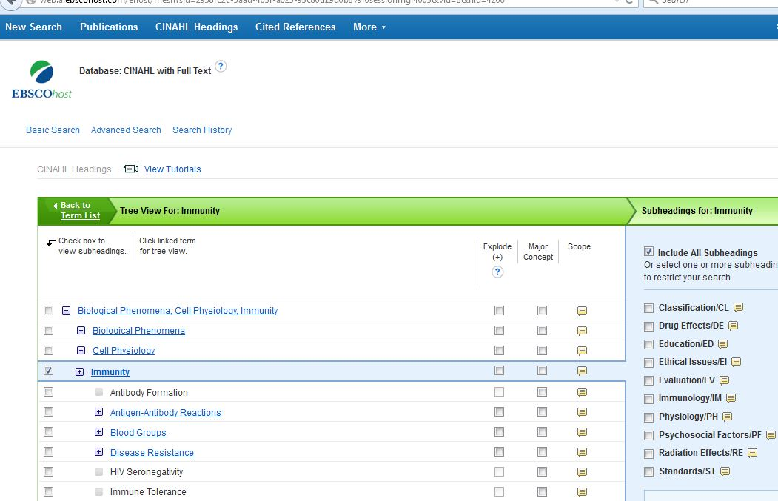

Subject Heading

Subheadings for Immunity

3. Search Limits
Subject Tree Record

There are several ways to limit you search.
-Limit to “Linked Full Text.” This will cause only full-text articles to be returned as part of the search set.
-Limit to “Peer Reviewed”. This will cause only scholarly journal articles to be returned as part of the set.
-Limit by “Publication Year.” Search for articles published in a specific timeframe.
-Limit by “Author.” Search for articles by a specific author.
-Limit by “Publication.” Search for article in a specific journal

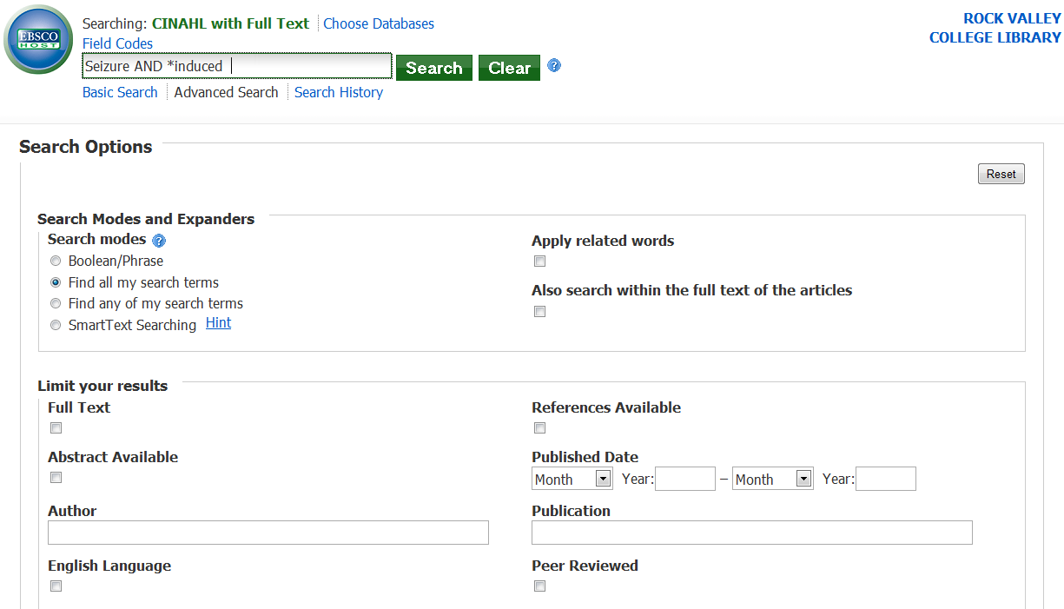
Full-Text
Peer Reviewed
Publication Dates
Author
Publication

4. Start the search
Keyword Search Click the search button to retrieve articles.
Search
CINAHL Headings Search
1. Activate CINAHL Headings from the toolbar on the top of the CINAHL start page.

1. Activate Headings

2. Check the box next to a concept
3. Click Search Databases button to retrieve articles.
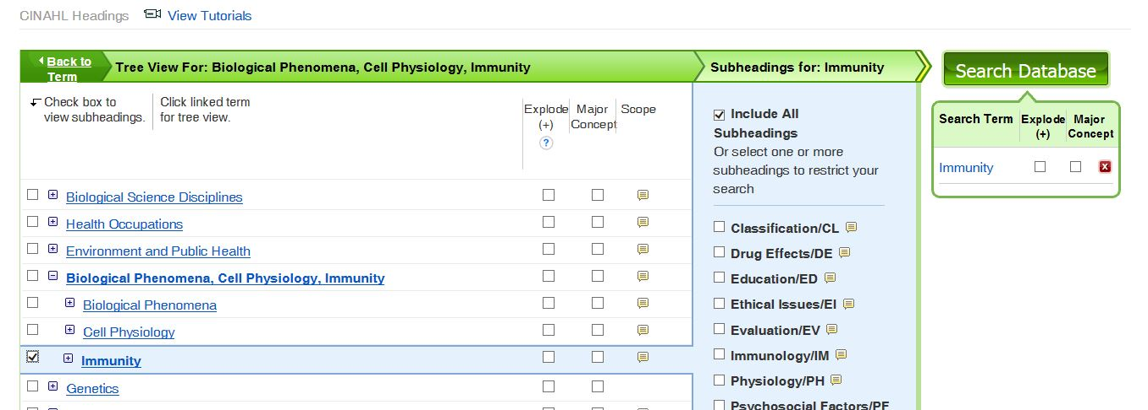
3. Search
2. Check the box

Viewing the Search Results

The results of your search will be displayed after you click on the Search button. The number of records or citations that have been returned will be shown in the All Results field. To Limit your search results to articles that are available in full text or have been recently published, find the Refine column on the left and make changes. The Update button is used to display Results that reflect these changes. To access the record, click on the title of the article. Also, if the article is available in full-text, a link will be present. Click on the PDF Full Text link to open the article.

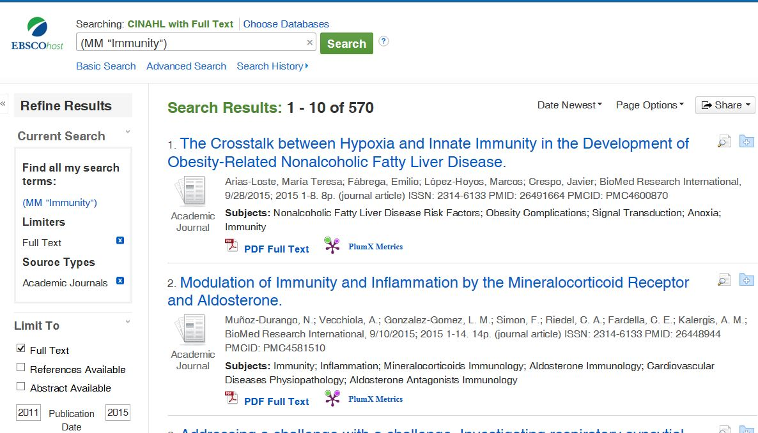
Refine Search
Number of Records
Article Record
Article Title
Full-Text Link
Clicking on the title of the article will open up the complete record for the article. This will include all the necessary items need to correctly cite the article including the article title, author(s), source (journal name), and volume, issue, and date information. The record will also include subject headings which are terms that describe what the article is about. An abstract (summary) of the article may also be present.
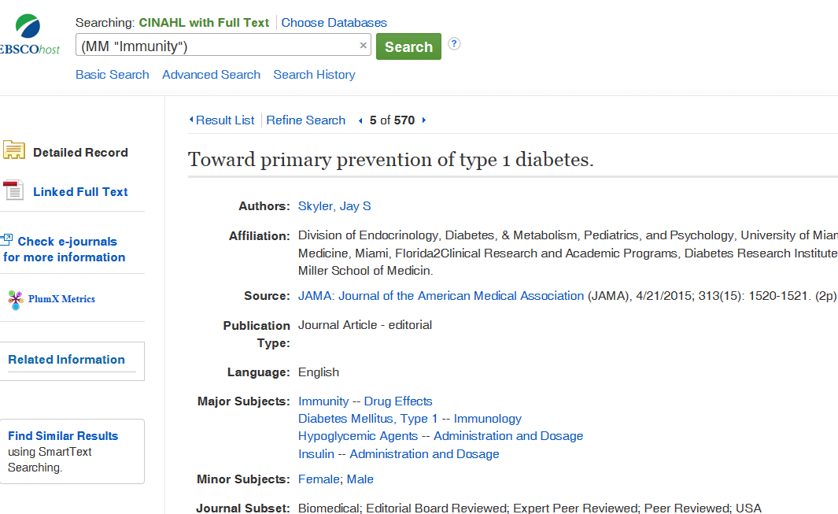
Article Title
Author(s)
Journal Title
Subject headings
Date
Volume, issue Number
Journal Title
Journal Title
Page Numbers

Other Features of CINAHL with Full Text

-Print, Save, E-mail, Cite. After you have selected and opened an individual article record, Use the Tools on the right side of the article to save a link to the article, print or e-mail the article, and keep the citation to the article in style required for your assignment (MLA, APA, Chicago etc).
Print
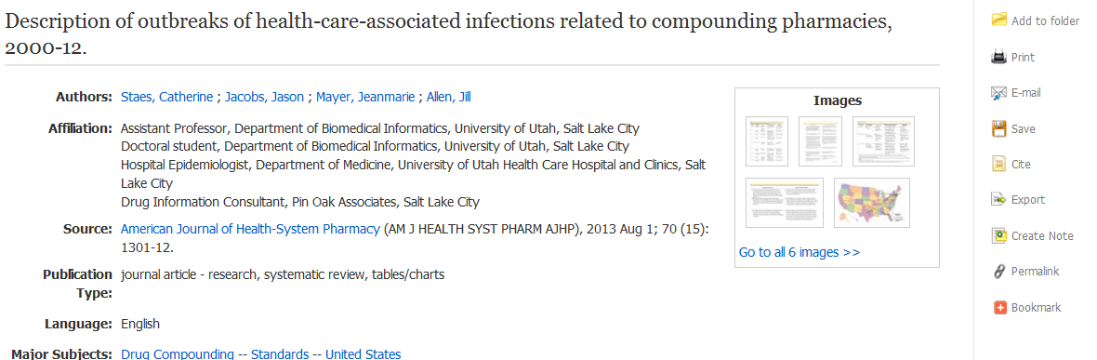
To save or print the PDF version of an article, click on Download PDF or click on printer icon. 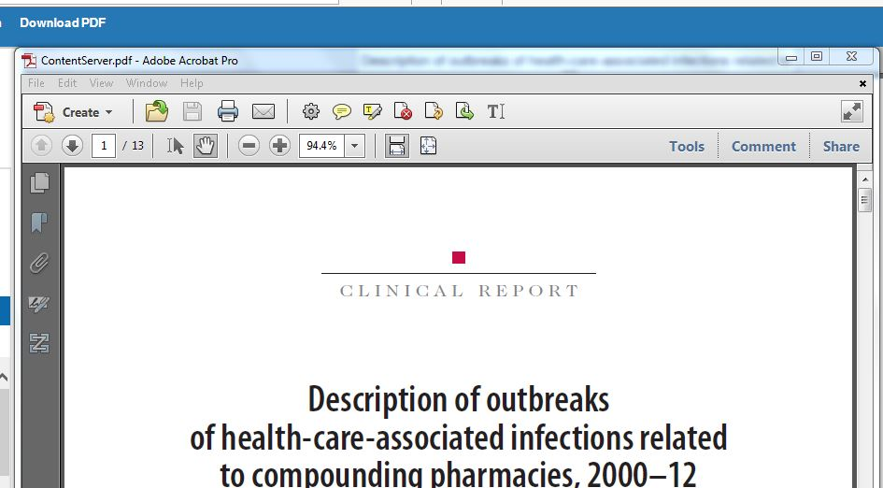
Print
Save
Save

E-mail
Cite
Revised by Steve Thompson 4/16, 8/13 from original by Scott Goldy 8/07 Estelle M. Black - Library Rock Valley College

